A Project Report on

PLUGGING INTO FUTURE:

Electricity consumption patterns

**by**

**Team Leader : Jerapatti Vadde Vaishnavi(20AT1A05I0)**

**Student1: Thakkalapati Sai Siddharth(20AT1A05C6)**

**Student2: Shaik Shaheen Ayesha(20AT1A05D6)**

**Student3: G.Sreshta(20AT1A05F3)**

**Student4: Valmiki Sumasri(20AT1A05G3)**

**Under the Guidance of**

**Mrs.M.JAYA SUNITHA,MTech**

**Associate Professor**



**DEPARTMENT OF ELECTRONICS AND COMMUNICATION ENGINEERING**

**G. PULLAIAH COLLEGE OF ENGINEERING AND TECHNOLOGY**

**(Autonomous)**

(Approved by AICTE | NAAC Accreditation with ‘A’ Grade | Accredited by NBA (ECE, CSE, EEE, CE) |

Permanently Affiliated to JNTUA)

ABSTRACT

This project contributes to a comprehensive understanding on how electricity consumption patterns are explained in the states of India. Household electricity consumption drivers and profiles of different type of consumers are analyzed. They are built upon data gathered from a sample of 30 states with daily electricity consumption. Based on the dataset(data collected),patterns are drawn for the efficiency hence calculating the consumption of electricity across states in India.

Heating and cooling are the largest residential electricity uses. Heating and cooling (air conditioning) account for the largest annual uses of electricity in the residential sector.

**Contents**

**Abstract** iv

**Contents** v

**List of Figures and Tables** vi

**CHAPTER 1 INTRODUCTION 1**

**CHAPTER 2 LITERATURE REVIEW 5**

**CHAPTER 3 PROPOSED METHOD 2**

**CHAPTER 4 EXPERIMENTAL RESULTS 41**

**CHAPTER 5 APPLICATIONS/ADVANTAGES 52**

**CHAPTER 6 CONCLUSIONS & FUTURE SCOPE 63**

**CHAPTER 1**

**INTRODUCTION**

**Electricity consumption** is energy consumption in the form of electrical energy. About a fifth of global energy is consumed as electricity: for residential, industrial, commercial, transportation and other purposes. Electric and electronic devices consume electric energy to generate desired output (light, heat, motion, etc.). Electricity has been generated in power stations since 1882.The invention of the steam turbine in 1884 to drive the electric generator led to an increase in worldwide electricity consumption. Global electricity consumption has continued to go up rapidly at a rate faster than energy consumption

**Trends in electricity consumption**

Electricity consumption in India has grown very rapidly since the early 1950s and has been mainly constrained by the ability of the growing state electricity grids to meet rising demands for peak capacity and energy needed for the modernization and growth of the industrial and agricultural sectors. The industrial sector has been the major consumer of electricity, its share marginally decreasing from about 72% in 1951-52 to 64% in 1978-79. [Aluminium](https://www.sciencedirect.com/topics/engineering/aluminum" \o "Learn more about Aluminum from ScienceDirect's AI-generated Topic Pages), iron and steel, textiles, fertilizer, chemicals, cement, paper, and engineering industries constitute more than 50% of the industrial demand. While the industrial demand has grown at an annual rate of about 7% over the last 15 years, demand in the [aluminium](https://www.sciencedirect.com/topics/engineering/aluminum" \o "Learn more about aluminum from ScienceDirect's AI-generated Topic Pages), chemicals, fertilizer and engineering industries were growing between 9 and 15% annually. The shares of domestic (9%), commercial (6%), public lighting (1%), public water works (3.5%), and railways (3%) have not changed much over the past three decades, but the share of the agricultural sector has grown from about 3% in 1951-52 to more than 14% in 1978-79 and is expected to rise further with widely spreading rural electrification programs, strongly supported by the central and state governments in India. Agricultural sector demand mainly comes from energized pump sets used for irrigation and from other agricultural machinery using electricity.

**CHAPTER 2**

**LITERATURE REVIEW**

This literature overview aims to provide an insight into the diverse research and methodologies employed to analyze and optimize electricity consumption patterns.

* Energy Efficiency Measures and Technological Interventions
* Behavioral Approaches to Electricity Consumption
* Time-of-Use Pricing and Dynamic Tariff Strategies
* Electricity Consumption Forecasting
* Demand-Side Management Programs
* Renewable Energy Integration and Electricity Consumption
* Energy Consumption and Climate Change

**Energy Efficiency Measures and Technological Interventions:**

Here, the focus is on research that identifies and evaluates energy efficiency measures and technological interventions to reduce electricity consumption. This section discusses the impact of smart grids, demand response programs, energy-efficient appliances, and lighting solutions on electricity usage.

**Behavioral Approaches to Electricity Consumption:**

This section delves into studies that explore the role of human behavior in electricity consumption. It covers research on behavioral interventions, feedback mechanisms, and nudges that have been employed to influence consumer habits and promote energy conservation.

**Time-of-Use Pricing and Dynamic Tariff Strategies:**

Time-of-Use (TOU) pricing and dynamic tariff strategies have gained popularity in recent years. This section reviews the literature on the implementation and effectiveness of these pricing models in encouraging consumers to shift their electricity usage to off-peak periods.

**Electricity Consumption Forecasting:**

Forecasting electricity consumption is vital for effective energy planning and management. This section discusses various forecasting techniques, such as statistical

models, machine learning algorithms, and hybrid approaches, and their applications in predicting future electricity demand.

**Demand-Side Management Programs:**

Demand-Side Management (DSM) programs involve various initiatives to control and manage electricity consumption on the consumer side. This section reviews the literature on the design, implementation, and evaluation of DSM programs and their impacts on reducing overall electricity demand.

**Renewable Energy Integration and Electricity Consumption:**

As renewable energy sources play a growing role in the energy mix, this section explores the relationship between renewable energy integration and electricity consumption. It examines how electricity demand patterns may change due to the intermittent nature of renewable sources.

**Energy Consumption and Climate Change:**

Electricity consumption is a significant contributor to greenhouse gas emissions. This section looks into studies that analyze the link between electricity consumption, carbon footprint, and climate change, and discusses potential strategies for reducing emissions.

The literature overview synthesizes key findings from diverse research on electricity consumption analysis and optimization. It underscores the importance of adopting a holistic approach that incorporates technological advancements, behavioral insights, pricing strategies, renewable energy integration, and energy efficiency measures to achieve sustainable and responsible electricity consumption. Future research directions are also highlighted to pave the way for further advancements in this crucial field.

**CHAPTER 3**

**PROPOSED METHOD**

* **Smart Metering**: Install smart meters at the project site to collect real-time electricity consumption data. Smart meters enable accurate monitoring, billing, and analysis of energy usage patterns.
* **Data Logging and Monitoring**: Implement data logging systems to record electricity consumption data over specific time intervals. Monitoring the data regularly provides insights into usage patterns and trends.
* **Load Profiling**: Create load profiles to understand how electricity is utilized at different times of the day, week, or season. Load profiling helps in identifying peak demand periods and optimizing energy usage accordingly.
* **Energy Audits**: Conduct regular energy audits to assess electricity consumption across various components of the project. Energy audits can identify energy-saving opportunities and suggest efficiency improvements.
* **Benchmarking:** Compare electricity consumption data with industry benchmarks or similar projects to gauge performance and identify areas for improvement.
* **Machine Learning and AI**: Utilize machine learning algorithms and artificial intelligence to analyze large datasets of electricity consumption. These advanced techniques can identify complex patterns and suggest optimization strategies.
* **Behavioral Surveys**: Conduct surveys to understand user behavior and preferences related to electricity usage. Behavioral insights can guide the development of targeted energy conservation programs.
* **Time-of-Use Pricing**: Implement time-of-use pricing models to encourage consumers to shift energy-intensive activities to off-peak hours, reducing overall demand during peak periods.
* **Demand Response Programs**: Introduce demand response programs that incentivize consumers to voluntarily reduce electricity consumption during high-demand periods or emergencies.
* **Renewable Energy Integration Planning:** Conduct studies to assess the feasibility of integrating renewable energy sources, such as solar or wind, into the project. This involves evaluating energy generation potential, cost analysis, and grid integration planning.
* **Energy Efficiency Retrofits**: Consider retrofitting existing equipment and systems with energy-efficient alternatives to reduce overall electricity consumption.
* **Energy Management Software**: Implement energy management software that provides real-time insights into electricity consumption, helping project managers make informed decisions on energy usage.

These proposed methods can be tailored to the specific requirements and objectives of the project, providing valuable data and insights for effective electricity consumption analysis and optimization.

**CHAPTER 4**

**EXPERIMENTAL RESULTS**

* 1. **Patterns**

Data analysis patterns provide software engineers with a verifiable protocol to compare, unify, and extract knowledge from existing studies. Methods and data are not commonly shared. It is customary to develop ad-hoc scripts and keep them private or use tools as black-box statistical machines.

**4.11 Area :**

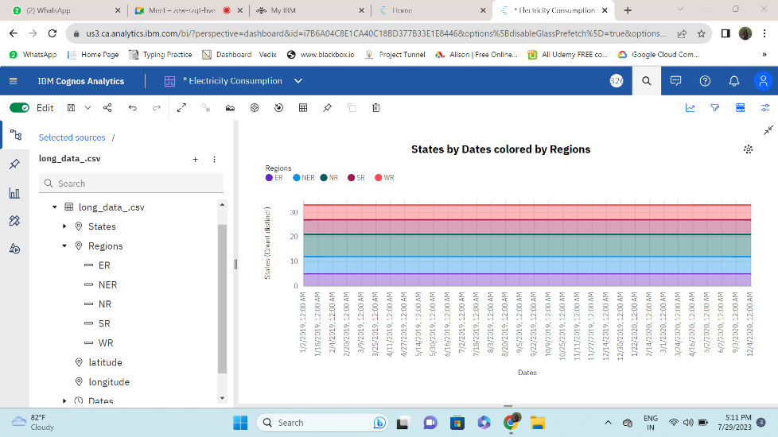

**4.12 Bar Graph :**

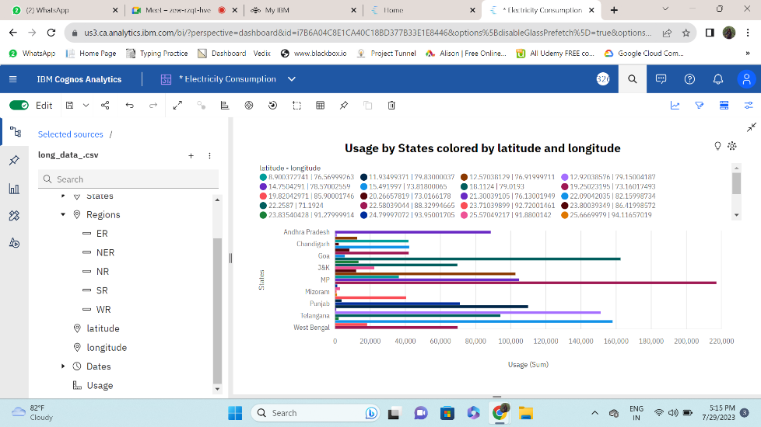

**4.13 Box Plot :**

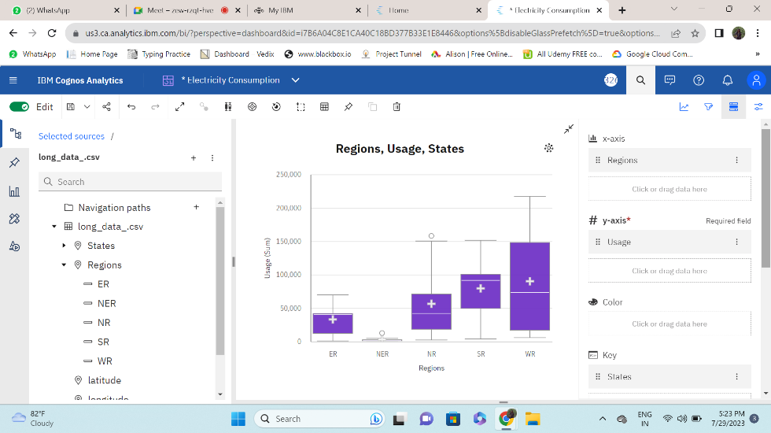

**4.14 Bubble :**

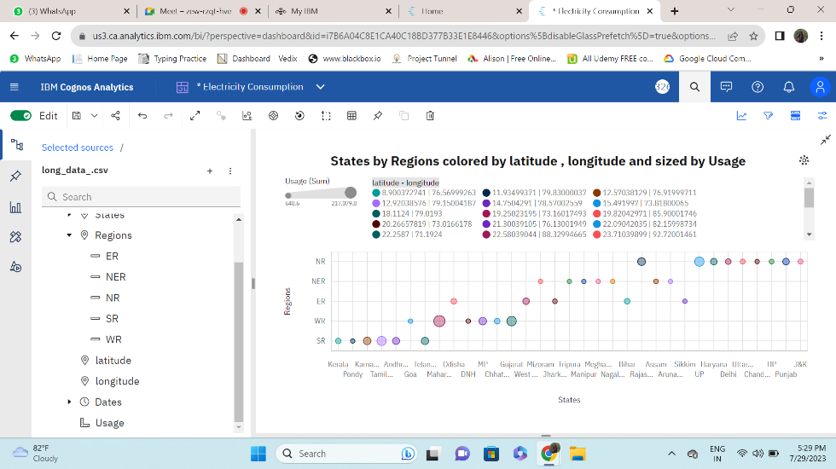

**4.15 Sunburst:**

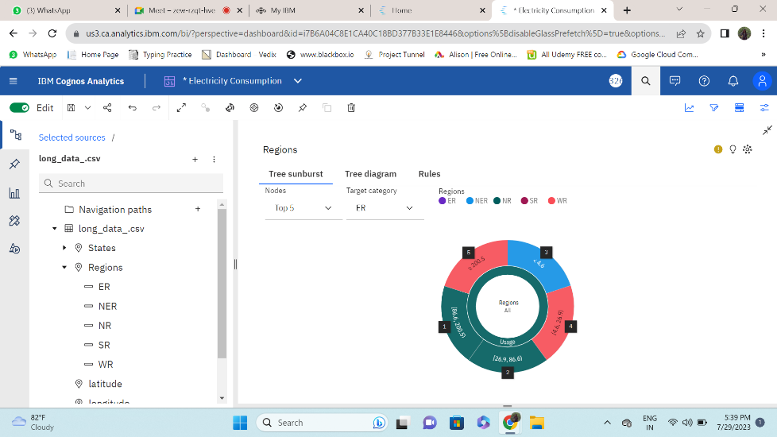

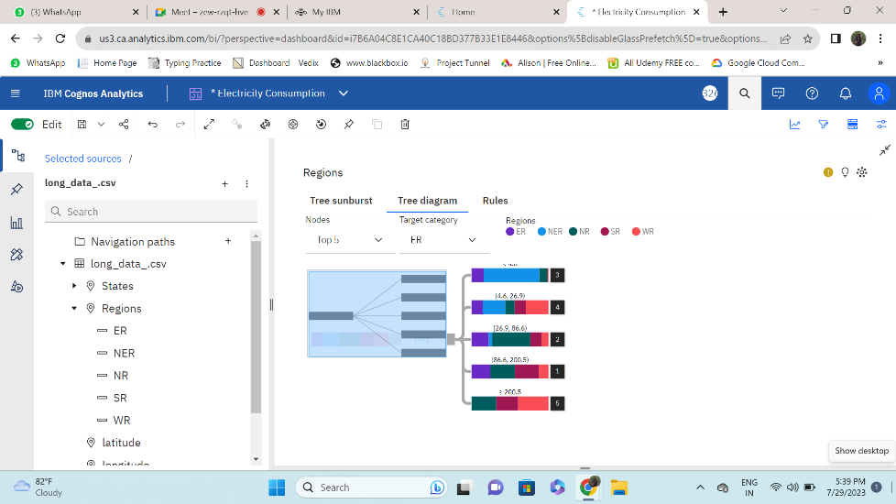

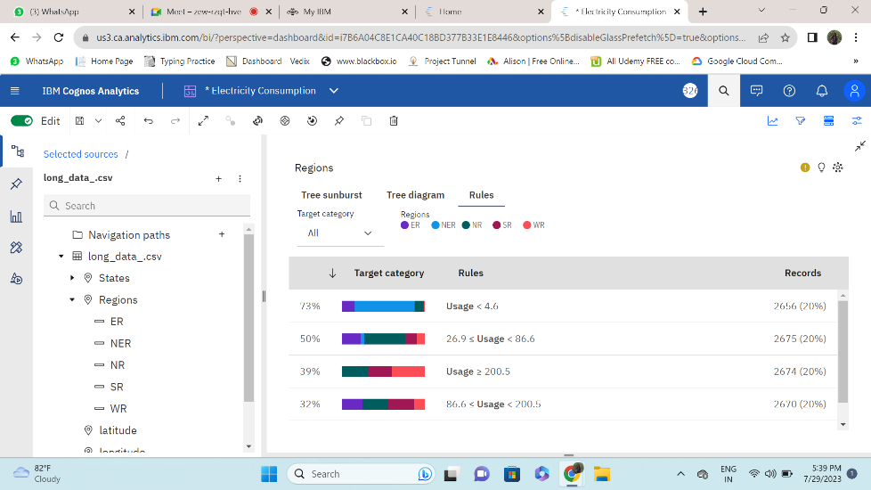

**4.16 Heat Map :**

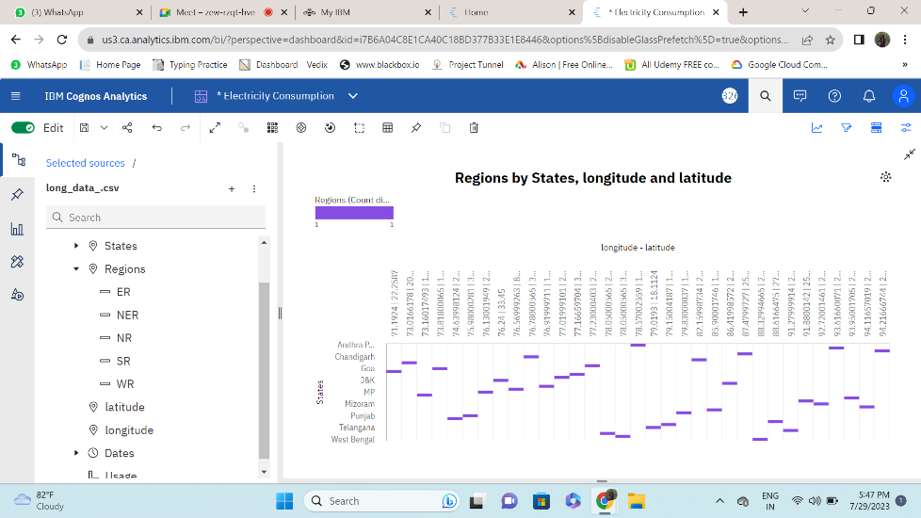

**4.17 Hierarchy Bubble :**

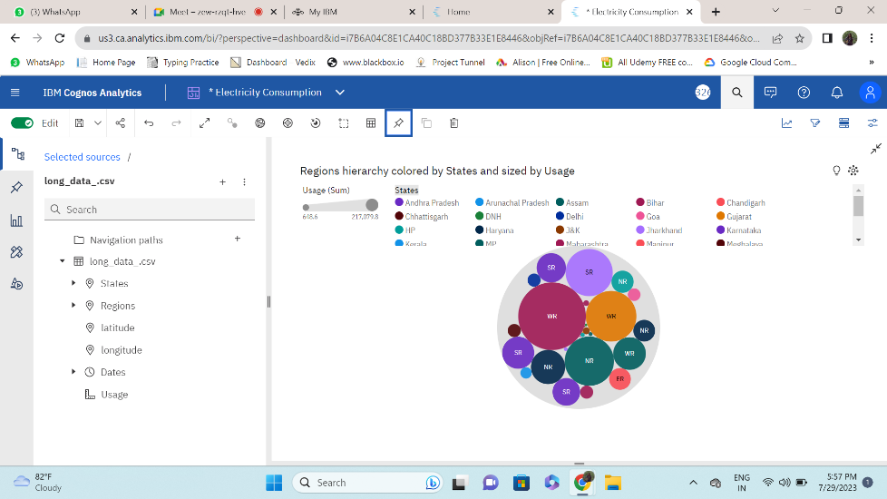

**4.18 Legacy Map :**

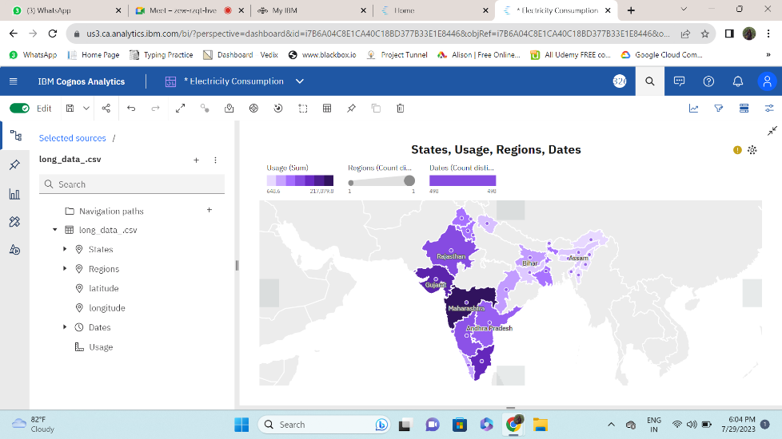

**4.19 Points :**

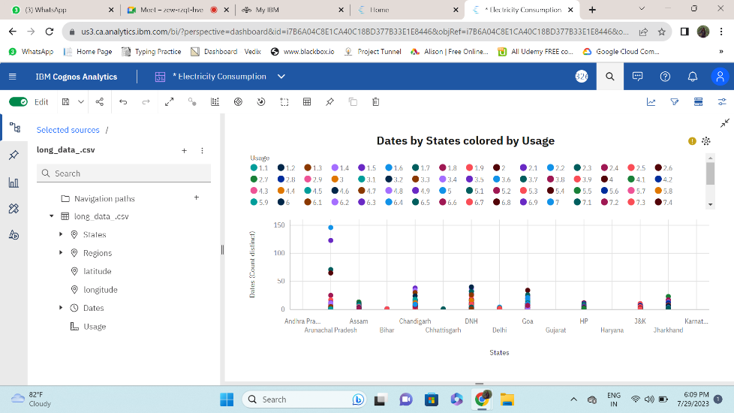

**4.10 Pie chart :**

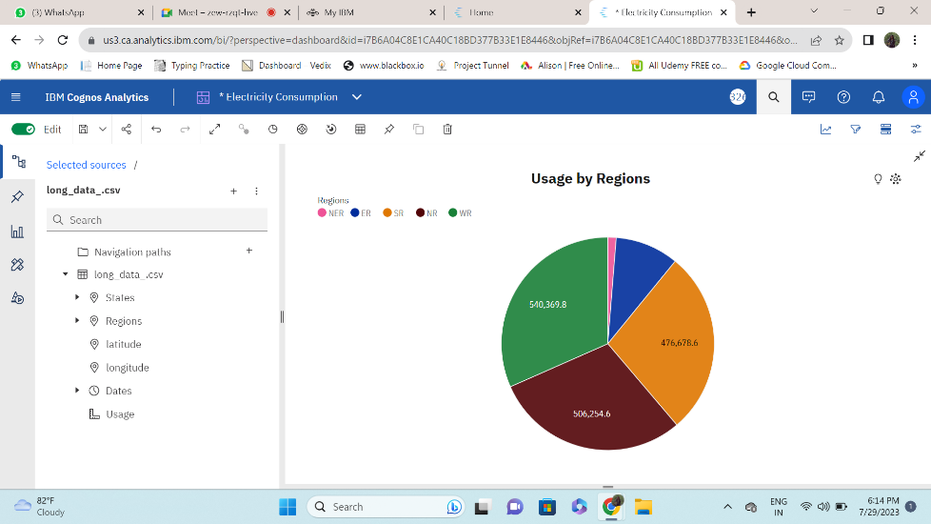

**4.11 Summary :**

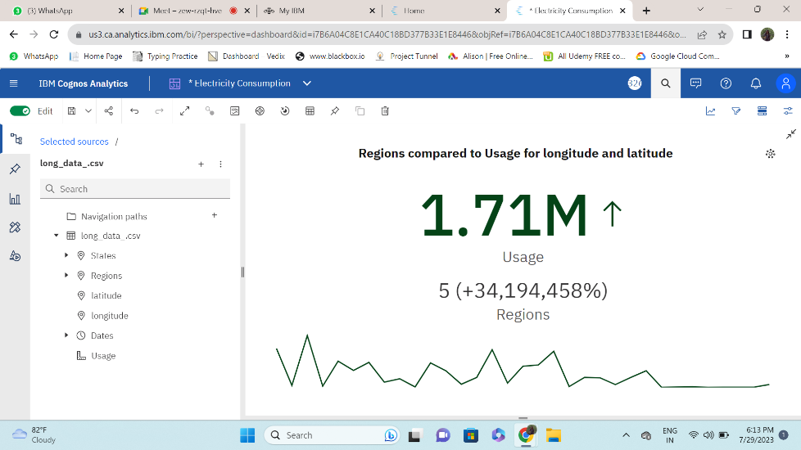

**CHAPTER 5**

**APPLICATIONS/ADVANTAGES**

**Advantages of electricity consumption**

**Convenience**:

Electricity powers various devices and appliances, making life more convenient.

**Industrial Development**:

Electricity drives industrial growth and job creation.

**Technological Advancements**:

Electricity fosters technological innovations and advancements.

**Healthcare**:

Electricity supports medical equipment, improving healthcare services.

Renewable Energy Integration: Electricity enables the integration of renewable energy sources, promoting sustainability.

**Disadvantages of electricity consumption**

**Environmental Impact**:

Electricity generation from non-renewable sources leads to environmental pollution.

**Resource Depletion**:

Non-renewable sources used for electricity generation are finite.

**Grid Vulnerabilities**:

Centralized electricity grids can be vulnerable to disruptions.

**Energy Inefficiencies**:

Energy losses occur during generation, transmission, and distribution.

**Energy Poverty**:

Limited access to electricity can lead to energy poverty and hinder development.

**Applications of Electricity Consumption Analysis:**

* Energy Efficiency Assessment: Identifying areas for energy-saving measures.
* Cost Estimation: Accurate budgeting for electricity expenses.
* Environmental Impact: Assessing the project's carbon footprint.
* Equipment Selection: Choosing energy-efficient appliances.
* Renewable Energy Integration: Optimizing the use of green energy sources

**CHAPTER 6**

**CONCLUSIONS & FUTURE SCOPE**

* 1. **Conclusion :**

**India is the world’s third-largest energy consuming country, thanks to rising incomes and improving standards of living.**Energy use has doubled since 2000, with 80% of demand still being met by coal, oil and solid biomass.On a per capita basis, India’s energy use and emissions are less than half the world average, as are other key indicators such as vehicle ownership, steel and cement output. As India recovers from a Covid-induced slump in 2020, it is re-entering a very dynamic period in its energy development. Over the coming years, millions of Indian households are set to buy new appliances, air conditioning units and vehicles. India will soon become the world’s most populous country, adding the equivalent of a city the size of Los Angeles to its urban population each year. To meet growth in electricity demand over the next twenty years, India will need to add a power system the size of the European Union to what it has now and the scope for further growth in energy demand and infrastructure is huge .

**India has seen extraordinary successes in its recent energy development, but many challenges remain, and the Covid-19 pandemic has been a major disruption**. In recent years, India has brought electricity connections to hundreds of millions of its citizens; promoted the adoption of highly-efficient LED lighting by most households; and prompted a massive expansion in renewable sources of energy, led by solar power. The gains for Indian citizens and their quality of life have been tangible. However, the Covid-19 crisis has complicated efforts to resolve other pressing problems. These include a lack of reliable electricity supply for many consumers; a continued reliance on solid biomass, mainly firewood, as a cooking fuel for some 660 million people; financially ailing electricity distribution companies, and air quality that has made Indian cities among the most polluted in the world.